========================================================================================
Dan Otieno. EE 384 -> Spring '24. Final Project - Speech Recognition. Due date: 04/08/24. This program combines python and MATLAB functionalities to... ...read, process and transcribe a wav audio file. Works cited: "Zhang, A. (2017). Speech Recognition (Version 3.8) [Software]. Available from https://github.com/Uberi/speech_recognition#readme." Instructions: 1. Run MATLAB script as "speechproject" (if in MATLAB console). 2. Select python script (speak.py). 3. Select .wav file when prompted (demoaudio.wav). 4. When script is done, see console output, and "transcribed.txt" file.
========================================================================================= 1

=========================================================================================
clear all; clc;
%-------------------------------------------------------------------------------------------
% Browse for Python file (.py extension specified).
[pythonScript, pythonScriptPath] = uigetfile('*.py', 'Select the Python script');
if pythonScript == 0
disp('No Python script selected. Exiting program now...');
return;
end
%-------------------------------------------------------------------------------------------
% Browse for audio file (using wav file for this implementation).
[audioFile, audioPath] = uigetfile('*.wav', 'Select an audio file');
if audioFile == 0
disp('No audio file selected. Exiting...');
return;
end
%-------------------------------------------------------------------------------------------
% Get audio file information.
audioFullPath = fullfile(audioPath, audioFile);
audioInfo = audioinfo(audioFullPath);
audioLengthSeconds = audioInfo.TotalSamples / audioInfo.SampleRate;
%-------------------------------------------------------------------------------------------
% Read the audio file and plot the signal waveform.
[y, Fs] = audioread(audioFullPath);
figure;
subplot(2,1,1);
plot((0:length(y)-1)/Fs, y);
xlabel('Time (s)');ylabel('Amplitude');grid on;
title('Audio Signal Waveform');
%-------------------------------------------------------------------------------------------
% Call Python script to transcribe audio and measure processing time.
tic;
[status, result] = system(['python "', fullfile(pythonScriptPath, pythonScript), '" "', audioFullPath, '"']);
processingTime = toc;
%-------------------------------------------------------------------------------------------
% Display transcription information.
if status == 0
disp('Transcription:');
disp(result);
% Plot the spectrogram.
subplot(2,1,2);
spectrogram(y(:,1), hamming(256), 128, 256, Fs, 'yaxis', 'centered');
title('Spectrogram');
%-------------------------------------------------------------------------------------------
% Save transcription output to a text file.
outputFile = 'transcribed.txt';
fid = fopen(outputFile, 'w');
fprintf(fid, '%s', result);
fclose(fid);
disp(['Transcription saved to ' outputFile]);
%-------------------------------------------------------------------------------------------
% Display additional information on console and save to text file.
additionalInfo = sprintf('\n\nAdditional Information:\nAudio Length: %.2f seconds\nSampling Rate: %d Hz\nProcessing Time: %.2f seconds', audioLengthSeconds, audioInfo.SampleRate, processingTime);
disp(additionalInfo);
fid = fopen(outputFile, 'a');
fprintf(fid, '%s', additionalInfo);
fclose(fid);
disp(['Additional information saved to ' outputFile]);
else
disp('Error occurred during speech-to-text conversion:');
disp(result);
end
%-------------------------------------------------------------------------------------------
Transcription:
I'm going to say just test test test test test test test test test test test and I speak I just throw in a couple of random words and with that recorded
Transcription saved to transcribed.txt
Additional Information:
Audio Length: 9.39 seconds
Sampling Rate: 44100 Hz
Processing Time: 6.41 seconds
Additional information saved to transcribed.txt
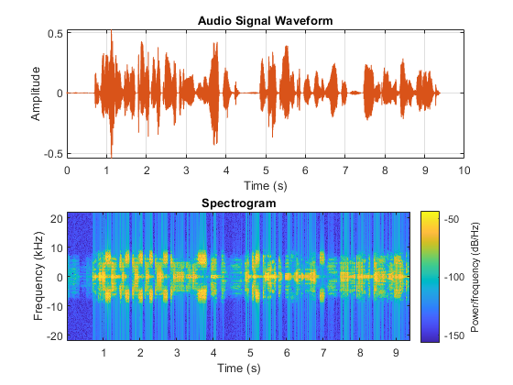
Published with MATLAB® R2023a

